CMSC 204

Huffman Lab

1. Create a Huffman Tree and generate the codes for each character of the following input:

create a huffman tree

For consistency:

1. If same frequency – put in priority queue alphabetically; put space before other characters of the same frequency
2. Add subtrees to end of group with same priority
3. Lower number has higher priority (goes to front)

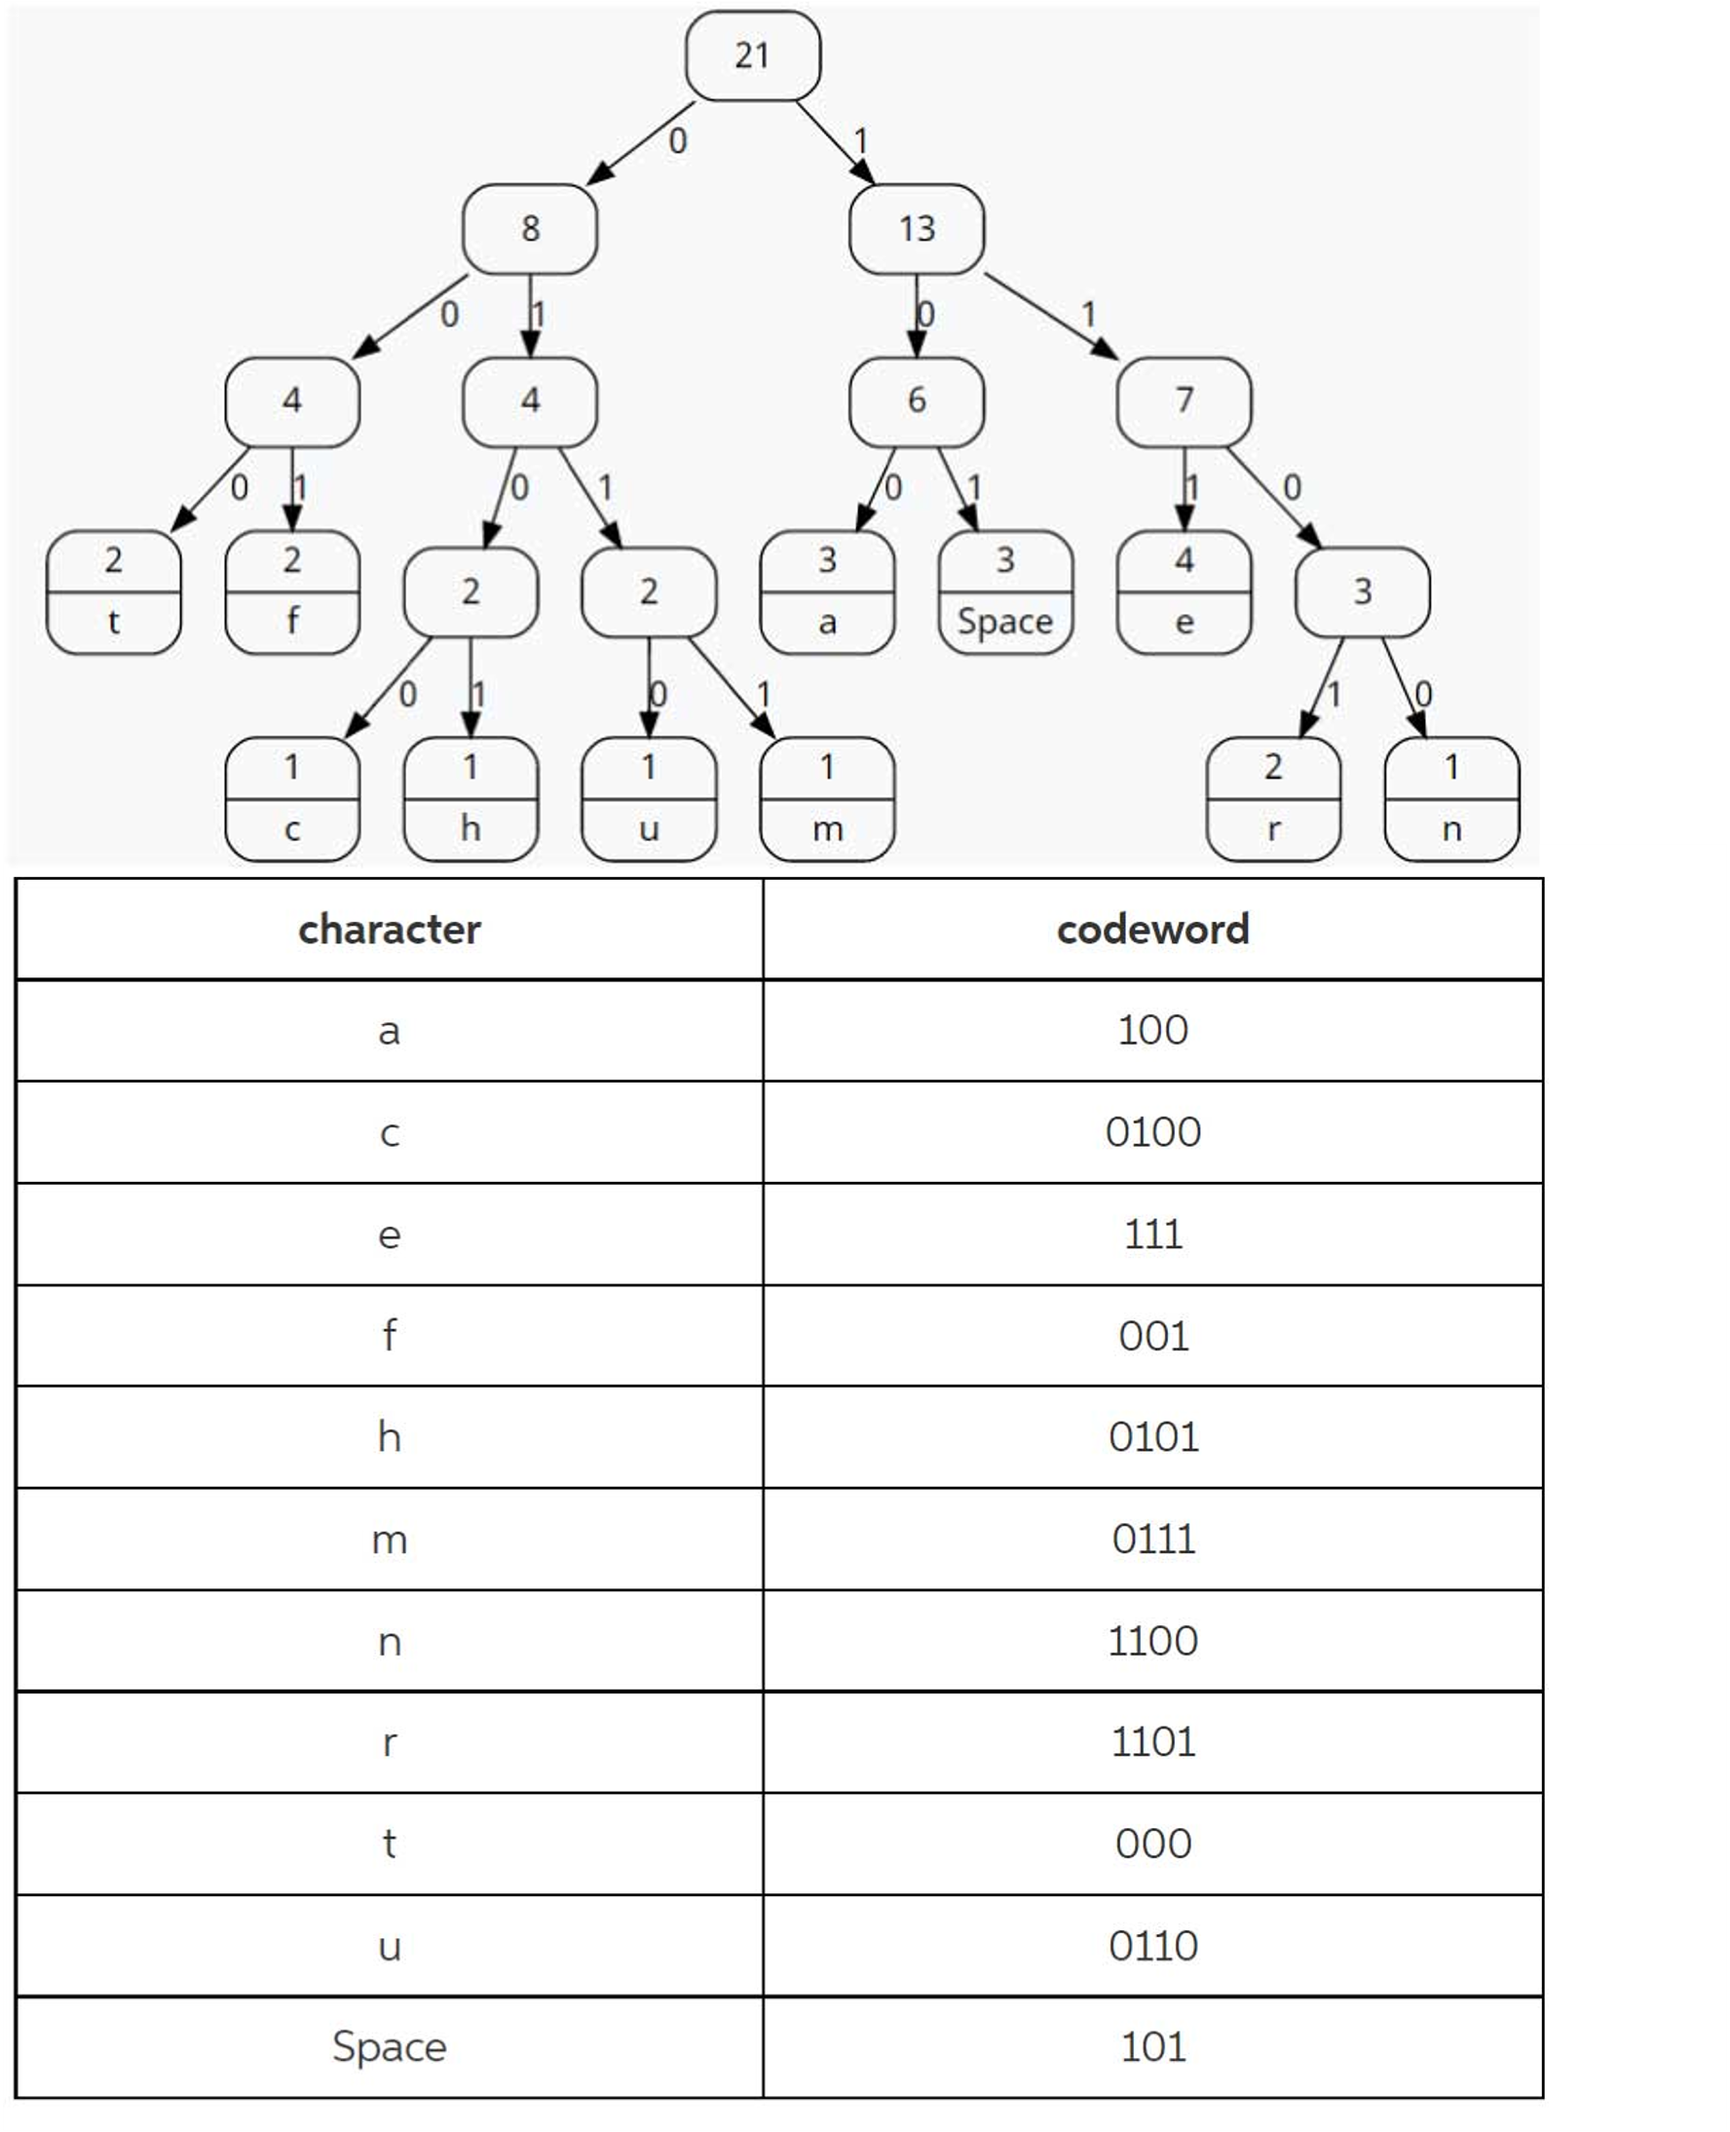

Encoded String: 0100110111110000011110110001010110001001011110011001010001101111111

1. Based on the following Huffman tree and binary sequence, what is the text

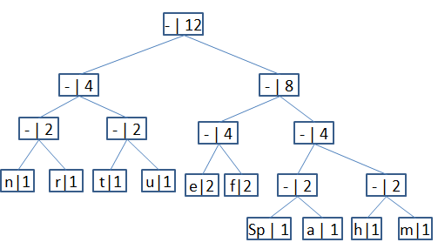

1110011101101111111010001100010001100100

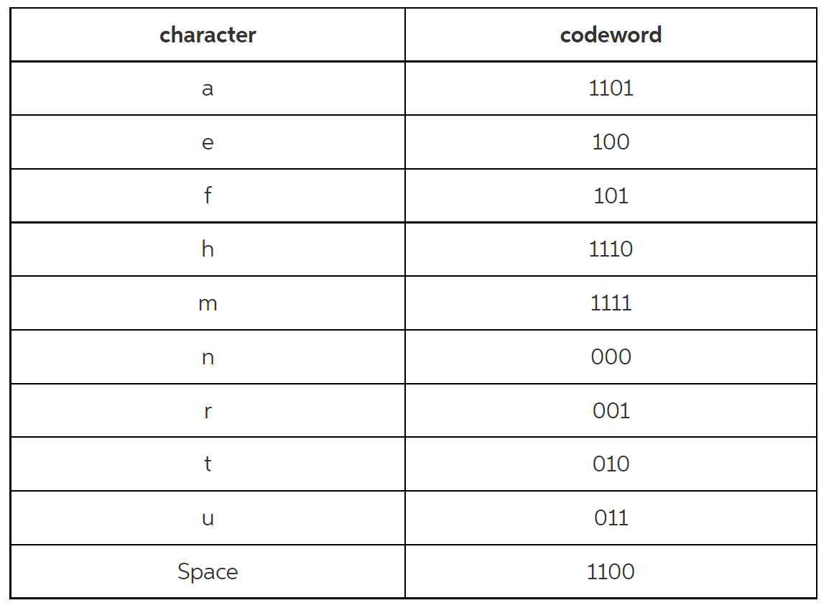

The text is : **huffman tree**